


Scope and Storyboard for Aviva MI User Front End

Aviva Team, Manchester

By Gareth Levingston

Table of Contents

1. Document Revision History 2
1.1. Document Location 2
1.2. Revision History 2
1.3. Reviewed by 2
1.4. Approvals (please complete ‘name’ column on first draft) 2
1.5. Distribution 2
2. Summary of Scope 3
3. Screen design 3
4. Workflow 3
5. Navigation 3
5.1. Where will the Flow be launched from 3
5.2. Where should the Flow return to 3
6. SQL Tables 3
6.1. Table 3
6.2. Lookup 3
6.3. Field 3
7. Stored Procedures 3
7.1. Fetch 3
7.2. Save 3
8. Document Templates 3
9. Javascript 3

Document Revision History

Document Location
Full File Path

Revision History
Version Number | Revision Date | Summary of Changes | Changes marked | Author
1.0 | 13/06/2012 | First issue | n/a | GQL

Reviewed by
Name | Signature | Title | Date of Issue | Version
Lisa Williams |  | Project Manager
Andrea Brown |  | Test Analyst

Approvals (please complete ‘name’ column on first draft)
Name | Signature or  Date of Approval Email | Title | Date of Issue | Version
Vivienne Williams
Mark Wheeler
Michael Pether
Nick Pargeter

Distribution
Name | Title | Date of Issue | Version

Summary of Scope

This scope describes the current MI requirement for Aviva as a client for excluding Disease work types in terms of Field Set with any required pick lists and subsequent data structure changes to accommodate the complete field set. This set is applicable to the following Group Code:
- AV-CC
- AV-CE
- AV-CH
- AV-HL
- AVIVA
- AV-MI

Screen design

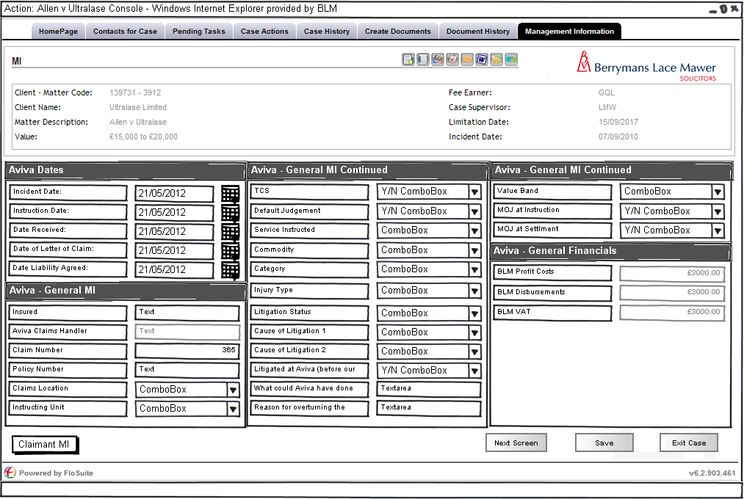
Figure 1 – Matter Centric MI Screen

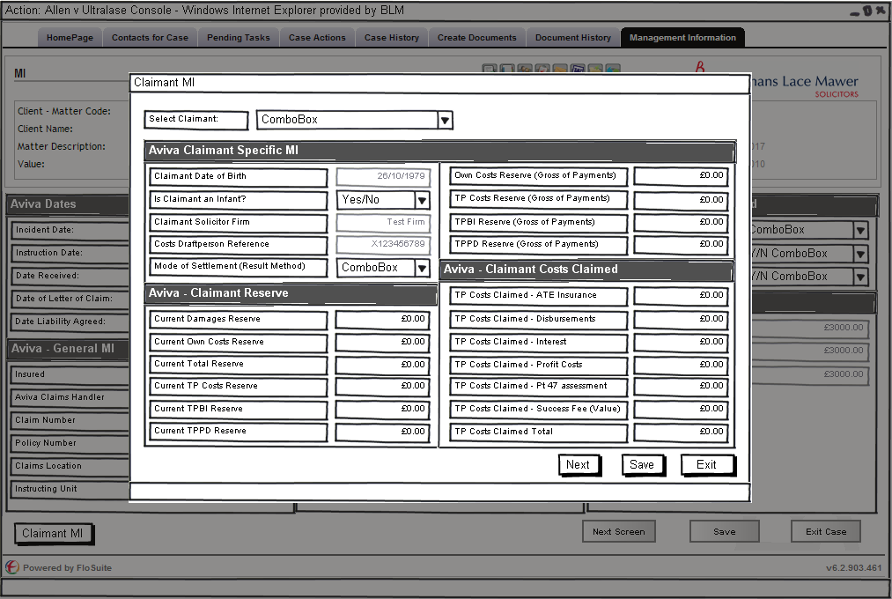
Figure 2 – Claimant Centric MI Screen 1
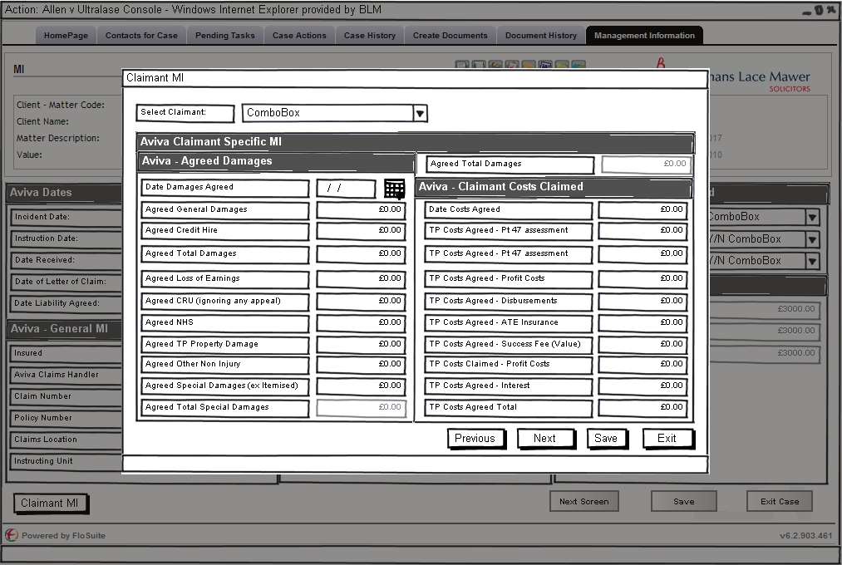
Figure 3 – Claimant Centric MI Screen 2
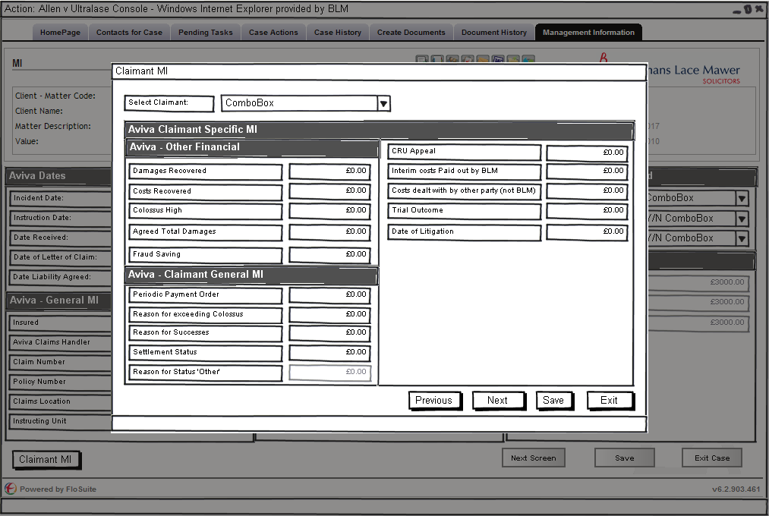
Figure 4 – Claimant Centric MI Screen 3

The above Four diagrams show the screen layout designs for the Aviva MI based on the following data provided by the MI team:

Matter Centric MI

Field Name | Format | Expert Field? | Existing MI Field? | Read Only? | Notes / DB Fields to use etc
Insured | text | No | Yes | No | FloCase contacts - same as AZ
Claim Number | text | No | Yes | No | same field as Z
Policy Number | text | No | Yes | No | Use FloCase ManagementInformation_PolicyNumber
Claims Location | picklist | No | Yes | No | ManagementInformation_ClntOffLoc - picklist on separate tab
Instructing Unit | picklist | No | Yes | No | ManagementInformation_ClntTeam - picklist on separate tab
TCS | Yes / No | No | No | No | New field?
Aviva Claims Handler | text | No | Yes | No | FloCase contacts - same as QBE
Incident Date | date | No | Yes | No | same field as Z
Instruction Date | date | No | Yes | No | Read write to Adrerant Matter user data [_HBM_Matter_Usr_Data].[Date_Instructed]
Date Received | date | No | Yes | No | KeyDates; Code = Receipt
Date of Letter of Claim | date | No | No | No | New field?
Date Liability Agreed | date | No | No | No | New field?
Default Judgement | Yes / No | No | Yes | No | CaseDetails_DefaultJudgmnt
Service Instructed | picklist | No | Yes | No | ManagementInformation_ServiceInstructed - picklist on separate tab
Commodity | picklist | No | Yes | No | Is the field CaseDetails_CourtTrack the standard track required by all cases - if so then new field - picklist on separate tab
Category | picklist | No | Yes | No | ManagementInformation_WorkType1 - picklist on separate tab
Injury Type | picklist | No | Yes | No | ManagementInformation_InjuryType - picklist on separate tab
Litigation Status | picklist | No | Yes | No | would like it to write to LitigationLiability_LitigatedPostInstrtn unless this causes a problem - picklist on separate tab
Cause of Litigation 1 | picklist | No | Yes | No | LitigationLiability_LitReason1 - picklist on separate tab
Cause of Litigation 2 | picklist | No | Yes | No | LitigationLiability_LitReason2 - picklist on separate tab
Litigated at Aviva (before our instruction) | Yes / No | No | No | No | New field?
What could Aviva have done differently to prevent litigation | free text | No | Yes | No | LitigationLiability_LitCauseText
MoJ at Instruction | Yes / No | No | Yes | No | Read write to Adrerant Matter user data [_HBM_Matter_Usr_Data].[MOJ_STAGE_CASE]
MoJ at Settlement | Yes / No | No | Yes | No | ManagementInformation_MOJSttldStts
Reason for overturning the Aviva claims handler decision | free text | No | No | No | New field?
Value Band | picklist | No | Yes | No | CaseDetails_WorkValueCode - picklist on separate tab
BLM Profit Costs | money | Yes | Yes | Yes | read only from Aderant - SQL to be provided
BLM Disbursements | money | Yes | Yes | Yes | read only from Aderant - SQL to be provided
BLM VAT | money | Yes | Yes | Yes | read only from Aderant - SQL to be provided

Claimant Centric MI

Field Name | Format | Expert Field? | Existing MI Field? | Read Only? | Notes / DB Fields to use etc
Claimant | text | No | Yes | No | FloCase contacts - same as AZ
Claimant DoB | date | No | Yes | No | FloCase contacts
Is Claimant an Infant? | Yes / No | No | No | No | New field?
Split Liability (with respect to other defendants) | Yes / No | No | Yes | No | [MIClaimantDetails_SplitLiability]
Allianz % Liability (with respect to other defendants) | percentage | No | Yes | No | [MIClaimantDetails_AllianzLiabilityDefendant]
Contributory Negligence | Yes / No | No | Yes | No | [MIClaimantDetails_ContributoryNegligence]
Allianz % Liability (with respect to contrib neg) | percentage | No | Yes | No | [MIClaimantDetails_AllianzLiabilityContribNeg]
Claimant Solicitor Firm Name | text | No | Yes | No | FloCase contacts - same as AZ
Date Damages Agreed (or went away if Repudiation or similar) | date | No | Yes | No | MIClaimantDetails_DamagesSettledDate
Damages Recovered | money | No | Yes | No | [MIClaimantDetails_DamagesRecovered]
Costs Recovered | money | No | Yes | No | [MIClaimantDetails_CostsRecovered]
Agreed Total Damages | money | No | Yes | Yes | MIClaimantDetails_TotalDamagesPaid; can this be a read only on screen field but write back to database with the sum General Damages and Total Special Damages fields below?
Agreed General Damages | money | No | Yes | No | [MIClaimantDetails_GeneralDamagesPaid]
Total Special Damages | money | No | Yes | Yes | [MIClaimantDetails_TotalSpecialDamagesPaid]; can this be a read only on screen field but write back to database to Financial_SpecialDamagesPaid with the sum of the 8 special damages figures below (rows 40-47)?
Agreed Special Damages (excluding those parts separately listed) | money | No | Yes | No | [MIClaimantDetails_SpecialDamagesPaidExcluding]
Agreed Credit Hire | money | No | Yes | No | [MIClaimantDetails_SpecialDamagesPaidCreditHire]
Agreed Loss of Earnings | money | No | Yes | No | Financial_LossEarnVal ????
Agreed Care | money | No | Yes | No | New Financial Field
Agreed CRU (ignoring any appeal) | money | No | Yes | No | [MIClaimantDetails_SpecialDamagesPaidCRU]
Agreed NHS | money | No | Yes | No | [MIClaimantDetails_SpecialDamagesPaidNHS]
Agreed TP Property Damage | money | No | Yes | No | [MIClaimantDetails_SpecialDamagesPaidPropertyDamage]
Agreed Other Non Injury | money | No | Yes | No | New Financial field?
Periodic Payment Order | Yes / No | No | No | No | New field?
Colossus High | money | No | Yes | No | Financial_ColossusValue??
Reason for exceeding Colossus | picklist | No | Yes | No | ManagementInformation_ColossusExReason - picklist on separate tab
Reason for Successes | picklist | No | Yes | No | ManagementInformation_SuccessReasn - picklist on separate tab
Fraud Saving | money | No | Yes | No | Financial_FraudSaving??
Settlement Status | picklist | No | Yes | No | MIClaimantDetails_ModeOfSettlement - picklist on separate tab
Reason for Status 'Other' | free text | No | No | No | New field?
CRU Appeal | picklist | No | Yes | No | New field? - picklist on separate tab
Interim costs Paid out by BLM | Yes / No | No | No | No | New field?
Date Costs Agreed (or went away if Repudiation or similar) | date | No | Yes | No | MIClaimantDetails_CostsSettledDate
Costs dealt with by other party (not BLM) | picklist | No | Yes | No | ManagementInformation_CostsResource - picklist on separate tab
Costs Draftperson Ref | text | No | Yes | No | This may be part of contacts?
TP Costs Claimed Total | money | No | Yes | Yes | [MIClaimantDetails_TotalTPCostsClaimed]; can this be a read only on screen field but write back to database with the sum of all the costs claimed figures below?
TP Costs Claimed - Pt 47 assessment | money | No | Yes | No | New Costs field?
TP Costs Claimed - Profit Costs | money | No | Yes | No | Costs_PCSCostsClaimed
TP Costs Claimed - Disbursements | money | No | Yes | No | Costs_PCSDisbClaimed
TP Costs Claimed - ATE Insurance | money | No | Yes | No | Costs_PTPATEClmd
TP Costs Claimed - Success Fee (Value) | money | No | Yes | No | Costs_PSuccessFeeClmd
TP Costs Claimed - Interest | money | No | Yes | No | New Costs field?
TP Costs Agreed Total | money | No | Yes | Yes | [MIClaimantDetails_TotalTPCostsPaid]; can this be a read only on screen field but write back to database with the sum of all the costs agreed figures below?
TP Costs Agreed - Pt 47 assessment | money | No | Yes | No | New Costs field?
TP Costs Agreed - Profit Costs | money | No | Yes | No | Costs_PCSCostsPaid
TP Costs Agreed - Disbursements | money | No | Yes | No | Costs_PCSDisbPaid
TP Costs Agreed - ATE Insurance | money | No | Yes | No | Costs_PATEPremiumPaid
TP Costs Agreed - Success Fee (Value) | money | No | Yes | No | Costs_PSuccessFeePaid
TP Costs Agreed - Interest | money | No | Yes | No | New Costs field?
TPBI Reserve (Gross of Payments) | money | No | Yes | No | New Reserve field? (GeneralDamagesGross?)
TPPD Reserve (Gross of Payments) | money | No | Yes | No | New Reserve field? (SpecialDamagesGross?)
TP Costs Reserve (Gross of Payments) | money | No | Yes | No | New Reserve field? (TPSCostGross?)
Own Costs Reserve (Gross of Payments) | money | No | Yes | No | New Reserve field? (BLMCostResGross?)
Current Total Reserve | money | No | Yes | Yes | FinancialReserve_Total; can this be a read only on screen field but write back to database with the sum of all the TPBI + TPPD + TP Costs + Own Costs current resreve fields below
Current Damages Reserve | money | No | Yes | Yes | FinancialReserve_Damages; can this be a read only on screen field but write back to database with the sum of all the TPBI + TPPD current reserve fields below
Current TPBI Reserve | money | No | Yes | No | FinancialReserve_GeneralDamages
Current TPPD Reserve | money | No | Yes | No | FinancialReserve_SpecialDamages
Current TP Costs Reserve | money | No | Yes | No | FinancialReserve_TPSCost
Current Own Costs Reserve | money | No | Yes | No | FinancialReserve_BLMCostRes
Trial Outcome | picklist | No | Yes | No | ManagementInformation_TrialOutcome - picklist on separate tab
Date of Litigation (Litigated post outsource cases only) | date | No | Yes | No | New Key Date field?

This filed set will be defined for the following Group Code:
- AV-CC
- AV-CE
- AV-CH
- AV-HL
- AVIVA
- AV-MI

Workflow

The following triggers with in the natural flow of a Matter should prompt the user to review the MI on that matter these are as follows:
- Settlement
- PLEASE ADD MORE IF REQUIRED

SQL Tables modifications

Lookup

The following new look ups are required
- Trial Outcome
  - Did not go to Trial
  - Won at Trial
  - Lost at Trial
- Value Band
  - £0 - £25k
  - £25k - £50k
  - £50k - £125k
  - £125k - £1million
  - £1million +
- Costs dealt with by other party (not BLM)
  - Yes
  - No
  - No Costs
- CRU Appeal
  - N/A
  - Ongoing
  - Successful
  - Unsuccesful
- Settlement Status
  - Passed to Cost Draughtsman
  - Handed to new firm
  - Settled - Part 36 offer awarded
  - Case Won
  - Case withdrawn
  - Settled - costs not awarded
  - Completed - Costs Agreed
  - New handler
  - Litigated
  - Settled before Trial
  - Lost at Trial
  - Other - please give reason
- Reason for Successes
  - Liability Success
  - Win at Trial
  - Offer not beaten
  - Own Costs Recovered
  - Successful CRU appeal
  - Predictive costs agreed on a litigated matter
  - Part 36 not Beaten
  - Fraud
- Reason for exceeding Colossus
  - Court Award
  - Case Law
  - Further Medical
  - JSB Guidelines
  - Not Exceeded
  - Other Factors
  - No Colossus valuation supplied
- Claims Location
  - Basildon
  - Belfast
  - Birmingham
  - Bishopbriggs
  - Bradford
  - Bristol
  - Chelmsford
  - Croydon
  - Dundee
  - Edinburgh
  - Exeter
  - Glasgow
  - India - Bangalore
  - India - Noida
  - India - Pune
  - Leeds
  - Liverpool
  - Manchester
  - Newcastle
  - Norwich Commercial Centre
  - Other
  - SIU
  - Southampton
  - Southend
  - TCS - Legal
  - TCS - Liability
  - TCS - Motor
  - Worthing
- Instructing Unit
  - Bangalore
  - Beachcroft
  - Berrymans Lace Mawer
  - Birmingham
  - Capita
  - Crawfords
  - CIP
  - Cunningham Lindsey
  - DLA
  - DWF
  - Exeter
  - Glasgow
  - Greenwoods
  - Horwich Farrelly
  - Hugh James
  - Keoghs
  - Manchester
  - Noida
  - Norwich
  - Other
- Service Instructed
  - Litigated
  - Litigated post outsource
  - Outsourced new claim
  - Outsourced caseload
  - Other
- Commodity
  - Criminal Prosecutions
  - Fraud
  - FT DA
  - FT non DA
  - Household
  - HSE
  - MT DA
  - MT non DA
  - PAD
  - Infant Approval
  - Consent Order
  - Other
  - Info only
  - Advice Only
- Category
  - Motor-Property Only
  - Motor-Injury
  - EL-injury
  - PL-injury
  - EL-Environmental
  - PL-Environmental
  - Professional Indemnity
  - PL-Property
  - Other
  - Credit Hire
- Injury Type
  - Amputation
  - Arm Injury (not broken)
  - Back Injury
  - Blindness/Injury to eyes
  - Brain Injury-Catastrophic
  - Brain Injury-Other
  - Breaks/Fractures
  - Burns/Scarring
  - Deafness/injury to ears
  - Cuts and Bruises
  - Fatality
  - Internal injuries
  - Leg injury (not broken)
  - Neck Injury
  - None
  - Psychological/Psychiatric
  - Paralysis
  - Shoulder Injury
- Litigation Status
  - Not litigated
  - Litigated
  - Part 8 only
  - Litigated post outsource
  - PAD
  - Infant Approval
  - Credit Hire only
- Cause of Litigation 1
  - Liability
  - Quantum
  - Liability & Quantum
  - Limitation
  - No response from Aviva
  - Other
- Cause of Litigation 2
  - No offer made by Aviva
  - Aviva offer rejected by claimant
  - Claimant offer rejected by Aviva
  - No response to Claimant offer
  - No response from Aviva
  - Disputed in Full
  - Other

/tmp/lo/0000.doc

